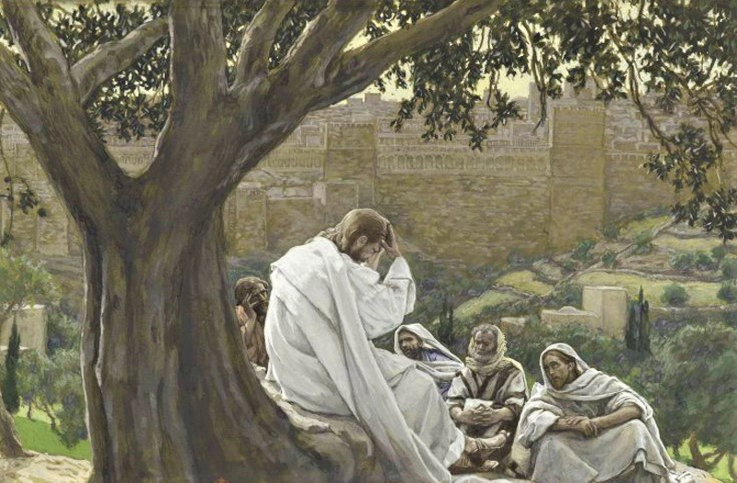

Trinity Episcopal Church of Niles
Pentecost XXI
Lectionary Proper 28, Year C
November 16, 2025 at 9:30 a.m.

An Order of Worship for
THE HOLY EUCHARIST

Congregational responses are in BOLD print.

THE ASSEMBLY GATHERS

Musical Prelude – “Third Sonatina Mvt II” W. Gillock
GREATINGS AND ANNOUNCEMENTS

Opening Processional – “How firm a foundation”
Hymn #636
ACCLAMATION AND COLLECT OF THE DAY

We frame our time of worship with an acclamation of God’s presence among us followed by a prayer that “collects” the themes of this particular day and season on the Christian calendar. We respond by singing a hymn of praise.

Presider Blessed be God: Father, Son, and Holy Spirit.
Assembly And blessed be his kingdom now and for ever. Amen.

Almighty God, to you all hearts are open, all desires known and from you no secrets are hid: Cleanse the thoughts of our hearts by the inspiration of your Holy Spirit, that we may perfectly love you, and worthily magnify your holy Name; through Christ our Lord. Amen.

Gloria Hymn #S280
Glory to God in the highest and peace to his people on earth.
Lord God, heavenly King, almighty God and Father,
we worship you, we give you thanks, we praise you for your glory.
Lord Jesus Christ, only Son of the Father, Lord God, Lamb of God,
You take away the sin of the world: have mercy on us;
You are seated at the right hand of the Father: receive our prayer,
For you alone are the Holy One, you alone are the Lord,
You alone are the Most High, Jesus Christ with the Holy Spirit,
in the glory of God the Father. Amen.

Collect of the Day
Presider The Lord be with you.
Assembly And also with you.
Presider Let us pray.

Blessed Lord, who caused all holy Scriptures to be written for our learning: Grant us so to hear them, read, mark, learn, and inwardly digest them, that we may embrace and ever hold fast the blessed hope of everlasting life, which you have given us in our Savior Jesus Christ; who lives and reigns with you and the Holy Spirit, one God, for ever and ever. Amen.

READINGS FROM SCRIPTURE

Our worship continues with passages from the Hebrew Bible and the Christian Testament; these selections come from the “Revised Common Lectionary,” a three- year cycle of readings used throughout The Episcopal Church.

The First Reading: Isaiah 65: 17-25
For I am about to create new heavens and a new earth; the former things shall not be remembered or come to mind. But be glad and rejoice forever in what I am creating; for I am about to create Jerusalem as a joy, and its people as a delight. I will rejoice in Jerusalem, and delight in my people; no more shall the sound of weeping be heard in it, or the cry of distress. No more shall there be in it an infant that lives but a few days, or an old person who does not live out a lifetime; for one who dies at a hundred years will be considered a youth, and one who falls short of a hundred will be considered accursed. They shall build houses and inhabit them; they shall plant vineyards and eat their fruit. They shall not build and another inhabit; they shall not plant and another eat; for like the days of a tree shall the days of my people be, and my chosen shall long enjoy the work of their hands. They shall not labor in vain, or bear children for calamity; for they shall be offspring blessed by the Lord-- and their descendants as well. Before they call I will answer, while they are yet speaking, I will hear. The wolf and the lamb shall feed together, the lion shall eat straw like the ox; but the serpent-- its food shall be dust! They shall not hurt or destroy on all my holy mountain, says the Lord.

Reader The Word of the Lord.
Assembly Thanks be to God.

Canticle 9 The First Song of Isaiah Isaiah 12:2-6

Recited responsively; the Assembly recites after the first verse

Surely, it is God who saves me; *
I will trust in him and not be afraid.
For the Lord is my stronghold and my sure defense, *
and he will be my Savior.
Therefore you shall draw water with rejoicing *
from the springs of salvation.
And on that day you shall say, *
Give thanks to the Lord and call upon his Name;
Make his deeds known among the peoples; *
see that they remember that his Name is exalted.
Sing the praises of the Lord, for he has done great things, *
and this is known in all the world.
Cry aloud, inhabitants of Zion, ring out your joy, *
for the great one in the midst of you is the Holy One of Israel.

Glory to the Father, and to the Son, and to the Holy Spirit: *
as it was in the beginning, is now, and will be for ever. Amen.

The Second Reading: 2 Thessalonians 3:6-13
Now we command you, beloved, in the name of our Lord Jesus Christ, to keep away from believers who are living in idleness and not according to the tradition that they received from us. For you yourselves know how you ought to imitate us; we were not idle when we were with you, and we did not eat anyone's bread without paying for it; but with toil and labor we worked night and day, so that we might not burden any of you. This was not because we do not have that right, but in order to give you an example to imitate. For even when we were with you, we gave you this command: Anyone unwilling to work should not eat. For we hear that some of you are living in idleness, mere busybodies, not doing any work. Now such persons we command and exhort in the Lord Jesus Christ to do their work quietly and to earn their own living. Brothers and sisters, do not be weary in doing what is right.
Reader The Word of the Lord.
Assembly Thanks be to God.

The Gospel: Luke 21:5-19
Please stand if you are able

Sequence Hymn – “Christ, whose glory fills the skies”
Hymn #7

Gospeler The Holy Gospel of our Savior Jesus Christ according to Luke.
Assembly Glory to you Lord Christ.

When some were speaking about the temple, how it was adorned with beautiful stones and gifts dedicated to God, Jesus said, "As for these things that you see, the days will come when not one stone will be left upon another; all will be thrown down."
They asked him, "Teacher, when will this be, and what will be the sign that this is about to take place?" And he said, "Beware that you are not led astray; for many will come in my name and say, `I am he!' and, `The time is near!' Do not go after them.
"When you hear of wars and insurrections, do not be terrified; for these things must take place first, but the end will not follow immediately." Then he said to them, "Nation will rise against nation, and kingdom against kingdom; there will be great earthquakes, and in various places famines and plagues; and there will be dreadful portents and great signs from heaven.
"But before all this occurs, they will arrest you and persecute you; they will hand you over to synagogues and prisons, and you will be brought before kings and governors because of my name. This will give you an opportunity to testify. So make up your minds not to prepare your defense in advance; for I will give you words and a wisdom that none of your opponents will be able to withstand or contradict. You will be betrayed even by parents and brothers, by relatives and friends; and they will put some of you to death. You will be hated by all because of my name. But not a hair of your head will perish. By your endurance you will gain your souls."
Gospeler The Gospel of the Lord
Assembly Praise to you Lord Christ

The Sermon: The Rev. Teunisje (Tina) Velthuizen
A brief silence follows the sermon.

The Nicene Creed
Christian worship usually includes a shared statement of belief, which shapes our life together as the Body of Christ and can in turn inspire how we live in the world as Christian people. The following creedal statement is derived from the Council of Nicaea in the early fourth century, which has become a standard baseline for Christian belief; please stand as you are willing and able.

We believe in one God,
the Father, the Almighty,
maker of heaven and earth,
of all that is, seen and unseen.
We believe in one Lord, Jesus Christ,
the only Son of God,
eternally begotten of the Father,
God from God, Light from Light,
true God from true God,
begotten not made,
of one Being with the Father;
through Him all things were made.
For us and our salvation
He came down from heaven,
was incarnate of the Holy Spirit and the Virgin Mary
and became truly human.
For our sake he was crucified under Pontius Pilate;
He suffered death and was buried.
On the third day he rose again
in accordance with the Scriptures;
He ascended into heaven
And is seated at the right hand of the Father.
He will come again in glory to judge the living and the
dead, and his kingdom will have no end.
We believe in the Holy Spirit, the Lord, the giver of life,
who proceeds from the Father,
who with the Father and the Son is worshiped and
glorified,
who has spoken through the Prophets.
We believe in one holy catholic and apostolic Church
We acknowledge one baptism for the forgiveness of sins.
We look for the resurrection of the dead,
And the life of the world to come. Amen.

Prayers of the People
Form V Book of Common Prayer Page 389

A person appointed leads the Assembly in prayer; responses are in bold italics. The Confession of Sin focuses mostly on our shared faults (rather than only our individual shortcomings) as a way to re-commit ourselves to building a community that promotes justice, peace, and love. Standing is the classical posture for prayer.

For the holy Church of God, that it may be filled with truth and love, and be found without fault at the day of your coming, we pray to you, O Lord. We pray especially for Sarah, the Archbishop of Canterbury Elect, Sean our Presiding Bishop, Ann our Assisting Bishop, and Tina our Celebrant.
Lord, have mercy.

For all who fear God and believe in you, Lord Christ, that our divisions may cease, and that all may be one as you and the Father are one, we pray to you, O Lord.
Lord, have mercy.

For the mission of the Church, that in faithful witness it may preach the Gospel to the ends of the earth, we pray to you, O Lord.
Lord, have mercy.

For those who do not yet believe, and for those who have lost their faith, that they may receive the light of the Gospel, we pray to you, O Lord.
Lord, have mercy.

For this congregation, for those who are present, and for those who are absent, that we may be delivered from hardness of heart, and show forth your glory in all that we do. We pray for Irene, Lois, Karen, Flora, Bivian, Larry, Sharon, the Neumann family, Gini, John, Deacon Jim, Bruce, Carol, Gregory, Audrey, Cheryl, Amy, David, Douglas, and Rick, we pray to you, O Lord.
Lord, have mercy.

For all who have died in the communion of your Church, and those whose faith is known to you alone, that, with all the saints, they may have rest in that place where there is no pain or grief, but life eternal, we pray to you, O Lord.
Lord, have mercy.

The Presider offers a collect.

Confession of Sin
Presider Let us confess our sins against God and our neighbor.
Assembly Most merciful God,
we confess that we have sinned against you
in thought, word, and deed,
by what we have done,
and by what we have left undone.
We have not loved you with our whole heart;
we have not loved our neighbors as ourselves.
We are truly sorry and we humbly repent.
For the sake of your Son Jesus Christ,
have mercy on us and forgive us;
that we may delight in your will,
and walk in you ways,
to the glory of your Name. Amen
Presider Almighty God have mercy on you, forgive you all your sins
through our Lord Jesus Christ, strengthen you in all
goodness, and by the power of the Holy Spirit keep you in eternal life. Amen.

The Peace
Please feel free to exchange with each other a sign of the peace that God offers to all; a hug, a handshake, and spoken greeting are all perfectly acceptable ways to share peace.

Presider May the peace of the Lord be with you.
Assembly And also with you.

Birthdays or Anniversary Blessing

The Holy Communion
All baptized who hunger for God and feel drawn to the Table are welcome to receive the Eucharistic elements of communion in this parish.

The Eucharist (from a Greek word meaning “gratitude”) reflects an ancient pattern of giving thanks for God’s creative, redeeming, and saving work by offering bread and wine as tokens of our gratitude, which we then receive as symbols of Christ, the embodied promise of God’s abundant life and the coming realm of justice and peace for all.
The Offertory
If you wish to give to the parish there is a plate located at the front of the pews as you walk up to the communion rail for the Eucharist.

Offertory Hymn – “O day of God”
Hymn #601

The Great Thanksgiving Eucharistic Prayer A
Presider The Lord be with you.
Assembly And also with you.
Presider Lift up your hearts.
Assembly We lift them to the Lord.
Presider Let us give thanks to the Lord our God.
Assembly It is right to give him thanks and praise.

The Presider continues
It is right, and a good and joyful thing, always and everywhere to give thanks to you, Father almighty, Creator of heaven and earth.

Therefore we praise you, joining our voices with Angels and Archangels and with all the company of heaven, who for ever sing this hymn to proclaim the glory of your Name:

Sanctus
Holy, holy, holy Lord, God of power and might,
Heaven and earth are full of your glory.
Hosanna in the highest, Hosanna in the highest
Blessed is he who comes in the name of the Lord.
Hosanna in the highest, Hosanna in the highest

The Presider continues
Holy and gracious Father: In your infinite love you made us for yourself; and, when we had fallen into sin and become subject to evil and death, you, in your mercy, sent Jesus Christ, your only and eternal Son, to share our human nature, to live and die as one of us, to reconcile us to your, the God and Father of all.

He stretched out his arms upon the cross, and offered himself in obedience to your will, a perfect sacrifice for the whole world.

On the night he was handed over to suffering and death, our Lord Jesus Christ took bread; and when he had given thanks to you, he broke it, and gave it to his disciples, and said, “Take eat; This is my Body, which is given for you. Do this for the remembrance of me.”

After supper he took the cup of wine; and when he had given thanks, he gave it to them, and said, “Drink this, all of you: This is my Blood of the new Covenant, which is shed for you and for many for the forgiveness of sins. Whenever you drink it, do this for the remembrance of me.”
Therefor we proclaim the mystery of faith:

Presider and Assembly together
Christ has died.
Christ is risen.
Christ will come again.

The Presider continues
We celebrate the memorial of our redemption, O Father, in this sacrifice of praise and thanksgiving. Recalling his death, resurrection, and ascension, we offer you these gifts.
Sanctify them by your Holy Spirit to be for your people the Body and Blood of you Son, the holy food and drink of new and unending life in him. Sanctify us also that we may faithfully receive this holy Sacrament, and serve you in unity, constancy, and peace; and at the last day bring us with all your saints into the joy of your eternal kingdom.
All this we ask through your Son Jesus Christ. By Him, and with Him, and in Him, in the unity of the Holy Spirit all honor and glory is yours, Almighty Father, now and for ever. Amen.
The Lord’s Prayer
Presider And now, as our Savior Christ has taught us, we are bold to say
Presider and Assembly together
Our Father, who art in heaven,
hallowed be thy Name.
thy kingdom come,
thy will be done,
on earth as it is in heaven.
Give us this day our daily bread.
And forgive us our trespasses,
as we forgive those
who trespass against us.
And lead us not into temptation,
but deliver us from evil.
For thine is the kingdom,
And the power, and the glory,
for ever and ever. Amen.
Fractional Anthem #S164
Presider and Assembly together
Jesus Lamb of God: have mercy on us.
Jesus, bearer of our sins: have mercy on us.
Jesus, redeemer, redeemer of the world:
Give us your peace, give us your peace.
The Breaking of the Bread
The bread is broken as a sign of God’s own sacrificial love for the world, exemplified by the suffering and death of Jesus; we, too, are called to embody that self-giving love for a world in need. After the bread is broken, the following is said and then sung:
Presider Christ our Passover is sacrificed for us.
Assembly Therefore let us keep the feast.

Communion will be served at the altar rail. You may drink from the common cup or use the small glasses.

Communion Hymn – “Rejoice! Rejoice believers”
Hymn #68

Post Communion Prayer
Presider and Assembly together
Eternal god, heavenly Father,
you have graciously accepted us as living members
of your Son our Savior Jesus Christ,
and you have fed us with spiritual food
in the Sacrament of his Body and Blood.
Send us now into the world in peace,
and grant us strength and courage
to love and serve you
with gladness and singleness of heart;
through Christ our Lord. Amen.

Blessing
Closing Hymn – “Jesus calls us”
Hymn #550
Dismissal
Presider Go in peace to love and serve the Lord
Assembly Thanks be to God.

Musical Postlude – “To God on high all glory be” J.C. Bach

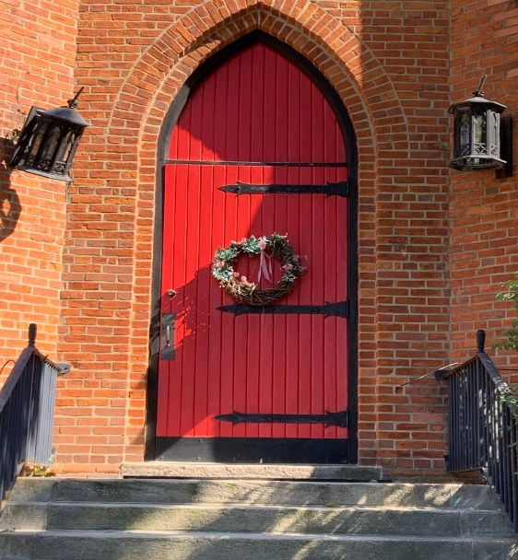

Trinity Parish
in the Episcopal Diocese of the Great Lakes
9 South 4th Street, Niles MI 49120
Office: (269) 683-6060
Email: trinityoffice5@yahoo.com
www.trinityniles.org
Office Hours: Tuesday & Thursday 10:00 a.m. – 2:00 p.m.

Vestry
Kathy Davies, Sr. Warden | Acolyte – Carol Krizinski
Elizabeth Rossow, Jr. Warden | Organist – Roland Seguin
Rhiannon Sanford, Clerk | Social Media – John Garmire
Beverly Archer
Gini Hupp | Digital Vergers
Carol Krizinski | Rhiannon Sanford
Dr. Sandy Reed | Zoe Hatfield
Jim Pederson | Shandelle Henson

