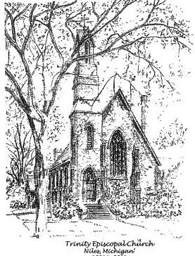

Trinity Episcopal Church of Niles
November 2nd , 2025
Twenty-first Sunday after Pentecost

Celebrant: Father John Shamm
Reader: Rhiannon Sanford
Acolyte: Carol Krizinski
Organist:
Coffee Hour:

Senior Warden: Kathy Davies
Junior Warden: Elizabeth Rossow
Clerk: Rhiannon Sanford
Vestry Members: Beverly Archer
Gini Hupp
Carol Krizinski
Dr. Sandy Reed
Jim Pedersen
Social Media: John Garmire

November Birthdays
11/6 Irene Williams 11/20 Sandy Reed
11/23 Flora Dsilva 11/26 Bruce Krzinski

Anniversaries
11/20 Gini & Dick Hupp

Announcements
Liturgy of the Word
Priest: Blessed be God: Father, Son, and Holy Spirit.
People: And blessed be his kingdom, now and for ever. Amen

Almighty God, to you all hearts are open, all desires known and from you no secrets are hid: Cleanse the thoughts of our hearts by the inspiration of your Holy Spirit, that we may perfectly love you, and worthily magnify your holy Name; through Christ our Lord. Amen

Gloria S280
Glory to God in the highest and peace to his people on earth.
Lord God, heavenly King, almighty God and Father,
we worship you, we give you thanks, we praise you for your glory.
Lord Jesus Christ, only Son of the Father, Lord God, Lamb of God, You take away the sin of the world: have mercy on us;
You are seated at the right hand of the Father: receive our prayer, For you alone are the Holy One, you alone are the Lord, You alone are the Most High, Jesus Christ with the Holy Spirit,
in the glory of God the Father. Amen.

Collect of the Day.
Priest: The Lord be with you.
People: And also with you.
Priest: Let us pray.

Almighty and merciful God, it is only by your gift that your faithful people offer you true and laudable service: Grant that we may run without stumbling to obtain your heavenly promises; through Jesus Christ our Lord, who lives and reigns with you and the Holy Spirit, one God, now and for ever. Amen

Our first reading is from Ecclesiasticus 2: 1-11

My child, when you come to serve the Lord prepare yourself for testing. Set your heart right and be steadfast and do not be impetuous in time of calamity. Cling to him and do not depart so that your last days may be prosperous. Accept whatever befalls you and in times of humiliation be patient. For gold is tested in the fire and those round acceptable in the furnace of humiliation. Trust in him and he will help you; make your ways straight and hope in him. You who fear the Lord wait for his mercy; do not stray of else you may fall. you who fear the Lord trust in him, and your reward will not be lost. You who fear the Lord, hope for good things, for lasting joy and mercy. Consider the generations of old and see: has anyone trusted in the Lord and been disappointed? Or has anyone persevered in the fear of the Lord and been forsaken? Or has anyone called upon him and been neglected? For the Lord is compassionate and merciful; he forgives sins and saves in time of distress.

Reader: The Word of the Lord.
People: Thanks be to God.

Psalm 149 all join in reading at the first asterisk

Hallelujah! Sing to the Lord a new song; * sing his praise in the congregation of the faithful.
Let Israel rejoice in his Maker, let the children of Zion be joyful in their King.
Let them praise his Name in the dance; let them sing praise to him with timbrel and harp.
For the Lord takes pleasure in his people and adorns the poor with victory.
Let the faithful rejoice in triumph; let them be joyful on their beds.
Let the praises of God be in their throat and a two-edged sword in their hand;
To wreak vengeance on the nations and punishment on the peoples;
To bind their kings in chains and their nobles with links of iron;
To inflict on them the judgment decreed; this is the glory for all his faithful people. Hallelujah!

Our Epistle reading is from the Letter of Paul to the
Ephesians 1:15-23

I have heard of your faith in the Lord Jesus and your love towards all the saints, and for this reason I do not cease to give thanks for you as I remember you in my prayers. I pray that the God of our Lord Jesus Christ, the Father of glory, may give you a spirit of wisdom and revelation as you come to know him, so that, with the eyes of your heart enlightened, you may know what is the hope to which he has called you, what are the riches of his glorious inheritance among the saints, and what is the immeasurable greatness of his power for us who believe, according to the working of his great power. God put this power to work in Christ when he raised him from the dead and seated him at his right hand in the heavenly places, far above all rule and authority and power and dominion, and above every name that is named, not only in this age but also in the age to come. And he has put all things under his feet and has made him the head over all things for the church, which is his body, the fullness of him who fills all in all.

Reader: The Word of the Lord.
People: Thanks be to God.

Gospel all standing

Priest: The Gospel of our Lord Jesus Christ according to
Luke 6: 20-31
People: Glory to you Lord Christ

Then he looked up at his disciples and said: ‘Blessed are you who are poor, for yours is the kingdom of God. ‘Blessed are you who are hungry now, for you will be filled. ‘Blessed are you who weep now, for you will laugh.
‘Blessed are you when people hate you, and when they exclude you, revile you, and defame you on account of the Son of Man. Rejoice on that day and leap for joy, for surely your reward is great in heaven; for that is what their ancestors did to the prophets.
‘But woe to you who are rich, for you have received your consolation. ‘Woe to you who are full now, for you will be hungry. ‘Woe to you who are laughing now, for you will mourn and weep. ‘Woe to you when all speak well of you, for that is what their ancestors did to the false prophets.
‘But I say to you that listen, Love your enemies, do good to those who hate you, bless those who curse you, pray for those who abuse you. If anyone strikes you on the cheek, offer the other also; and from anyone who takes away your coat do not withhold even your shirt. Give to everyone who begs from you; and if anyone takes away your goods, do not ask for them again. Do to others as you would have them do to you.

Priest: The Gospel of the Lord
People: Praise to you Lord Christ

Sermon Father John

Baptismal Covenant BCP p. 304

Celebrant |  | Do you reaffirm your renunciation of evil and  renew your commitment to Jesus Christ?
People |  | I do.
Celebrant |  | Do you believe in God the Father?
People |  | I believe in God, the Father almighty,  creator of heaven and earth.
Celebrant |  | Do you believe in Jesus Christ, the Son of God?
People |  | I believe in Jesus Christ, his only Son, our Lord.  He was conceived by the power of the Holy Spirit  and born of the Virgin Mary.  He suffered under Pontius Pilate, was crucified, died,  and was buried.  He descended to the dead.  On the third day he rose again.  He ascended into heaven, and is seated at the right  hand of the Father.  He will come again to judge the living and the dead.
Celebrant |  | Do you believe in God the Holy Spirit?
People |  | I believe in the Holy Spirit, the holy catholic Church,  the communion of saints, the forgiveness of sins,  the resurrection of the body, and the life everlasting.
Celebrant |  | Will you continue in the apostles' teaching and  fellowship, in the breaking of bread, and in the  prayers?
People |  | I will, with God's help.
Celebrant |  | Will you persevere in resisting evil, and, whenever  you fall into sin, repent and return to the Lord?
People |  | I will, with God's help.
Celebrant |  | Will you proclaim by word and example the Good  News of God in Christ?
People |  | I will, with God's help.
Celebrant |  | Will you seek and serve Christ in all persons, loving  your neighbor as yourself?
People |  | I will, with God's help.
Celebrant Will you strive for justice and peace among all people, and respect the dignity of every human being?
People I will, with God’s help.
Celebrant May Almighty God, the Father of our Lord Jesus Christ, who has given us a new birth by water and the Holy Spirit, and bestowed upon us the forgiveness of sins, keep us in eternal life by his grace, in Christ Jesus our Lord. Amen.

Prayers of the People are Form 3 BCP 387

Father, we pray for your holy Catholic Church; In our diocesan cycle of prayer we pray for the Standing Committee Members of the Episcopal Diocese of the Great Lakes and All Saints Church in Saugatuck - Jay Emerson Johnson, Rector
That we all may be one.

Grant that every member of the Church may truly and humbly serve you;
That your name may be glorified by all people.

We pray for all bishops, priests and deacons; especially our celebrant Father John.
That they may be faithful ministers of your Word and Sacraments.

We pray for all who govern and hold authority in the nations of the world;
That there may be justice and peace on the earth.

Give us grace to do your will in all that we undertake;
That our works may find favor in your sight.

Have compassion on those who suffer from any grief or trouble;
That they may be delivered from their distress.

We praise you for your saints who have entered into joy;
May we also come to share in your heavenly kingdom.

Let us pray for our own needs and those of others. We pray for Irene, Lois, Karen, Flora, Bivian, Larry, Sharon, the Neumann family, Gini, John, Deacon Jim, Bruce, Carol, Gregory, Audrey, Cheryl, Amy, David, Douglas, and Rick

Prayers for the departed.

Confession of Sin in your bulletin

God of all mercy, we confess that we have sinned against you,
opposing your will in our lives.
We have denied your goodness in each other, in ourselves, and in the world you have created.
We repent of the evil that enslaves us, the evil we have done, and the evil done on our behalf.
Forgive, restore, and strengthen us through our Savior Jesus Christ, that we may abide in your love and serve only your will. Amen.

Peace

Birthdays or Anniversary Blessing

Holy Communion

Be joyful in the Lord, all you lands; serve the Lord with
Gladness and come before his presence with a song.

Offertory Hymn: Hymn

Great Thanksgiving Eucharistic Prayer B BCP p. 367
Celebrant: The Lord be with you.
People: And also with you.
Celebrant: Lift up your hearts
People: We lift them to the Lord.
Celebrant: Let us give thanks to the Lord our God
People: It is right to give him thanks and praise

It is right, and a good and joyful thing, always and everywhere to give thanks to you, Father almighty, Creator of heaven and earth.

Therefore we praise you, joining our voices with Angels and Archangels and with all the company of heaven, who for ever sing this hymn to proclaim the glory of your Name:

Sanctus BCP p. 367
Holy, holy, holy Lord, God of power and might,
Heaven and earth are full of your glory.
Hosanna in the highest, Hosanna in the highest
Blessed is he who comes in the name of the Lord.
Hosanna in the highest, Hosanna in the highest

Prayer B continues stand or kneel BCP p. 367

We give thanks to you, O God, for the goodness and love which
you have made known to us in creation; in the calling of Israel to be your people; in your Word spoken through the prophets; and
above all in the Word made flesh, Jesus, your Son. For in these
last days you sent him to be incarnate from the Virgin Mary, to be the Savior and Redeemer of the world. In him, you have delivered us from evil, and made us worthy to stand before you. In him, youhave brought us out of error into truth, out of sin into
righteousness, out of death into life.

On the night before he died for us, our Lord Jesus Christ took
bread; and when he had given thanks to you, he broke it, and gave it to his disciples, and said, “Take, eat: This is my Body, which is given for you. Do this for the remembrance of me.”

After supper, he took the cup of wine; and when he had given
thanks, he gave it to them, and said, “Drink this, all of you: This ismy Blood of the new Covenant, which is shed for you and for
many for the forgiveness of sins. Whenever you drink it, do this for the remembrance of me.”

Celebrant: Therefore, according to his command, O Father,
People: We remember his death,
We proclaim his resurrection,
We await his coming in glory

And we offer our sacrifice of praise and thanksgiving to you, O Lord of all; presenting to you, from your creation, this bread and this wine.
We pray you, gracious God, to send your Holy Spirit upon these gifts that they may be the Sacrament of the Body of Christ and his Blood of the new Covenant. Unite us to your Son in his sacrifice, that we may be acceptable through him, being sanctified by the Holy Spirit. In the fullness of time, put all things in subjection under your Christ, and bring us to that heavenly country where, with all your saints, we may enter the everlasting heritage of your sons and daughters; through Jesus Christ our Lord, the firstborn of all creation, the head of the Church, and the author of our salvation.
By him, and with him, and in him, in the unity of the Holy Spirit all honor and glory is yours, Almighty Father, now and for ever. AMEN.

The Lord’s Prayer BCP p. 364
Our Father who art in heaven, hallowed be thy name. Your kingdom come, your will be done, on earth as in heaven. Give us this day our daily bread. And forgive us our trespasses, as we forgive those who trespass against us. And lead us not into temptation but deliver us from evil. For thine is the kingdom, and the power, and the glory, for ever and ever. Amen
Priest: Christ our Passover is sacrificed for us.
People: Therefore let us keep the feast.

Breaking of the Bread BCP p. 364
Fraction Anthem S 164
Jesus Lamb of God: have mercy on us.
Jesus, bearer of our sins: have mercy on us.
Jesus, redeemer, redeemer of the world:
Give us your peace, give us your peace.

Celebrant: The gifts of God for the People of God. Take them in remembrance that Christ died for you, and feed on him in your hearts by faith, with thanksgiving.

Communion Is served at the altar rail. You may drink from the common cup or use the small glasses.

Post Communion Prayer BCP p. 365
Eternal god, heavenly Father, you have graciously accepted us as living members of your Son our Savior Jesus Christ, and you have fed us with spiritual food in the Sacrament of his Body and Blood. Send us now into the world in peace, and grant us strength and courage to love and serve you with gladness and singleness of heart; through Christ our Lord. Amen
Blessing
Dismissal
Priest: Go in peace to love and serve the Lord
People: Thanks be to God.

Postlude:

Please follow/subscribe to our Social Media
Facebook – Trinity Episcopal Church, Niles MI
Instagram – TrinityEpiscopalNiles
YouTube Channel – Trintiy Episcopal Niles
Website - www.trinityniles.org,
Email – trinityoffice5@yahoo.com



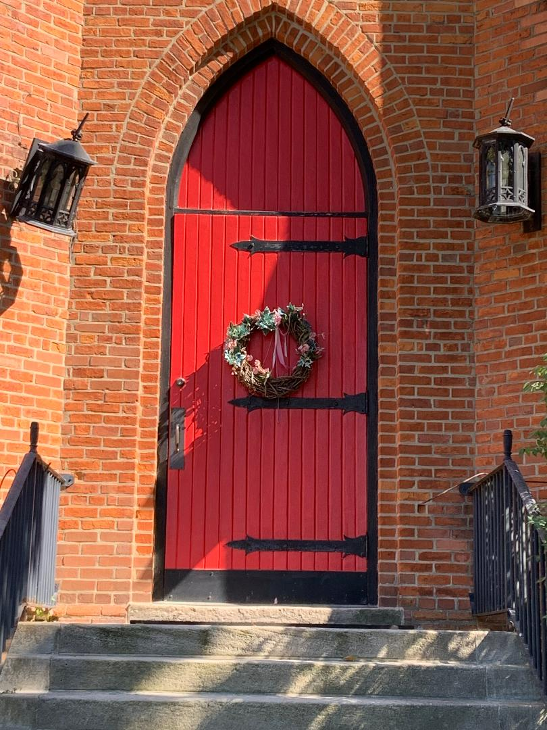

Our red door welcomes everyone

