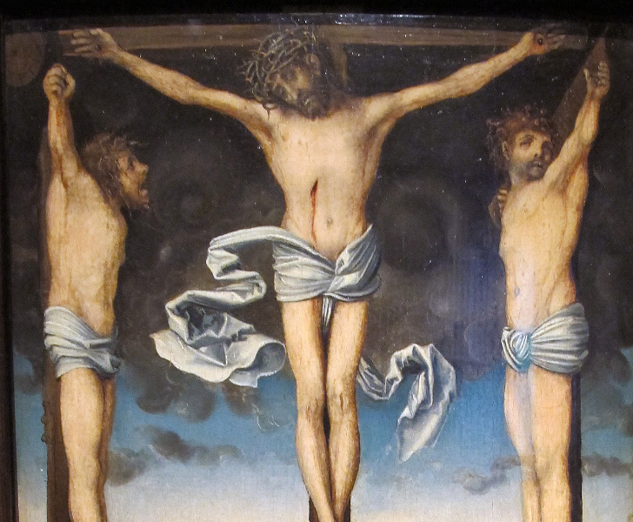

Trinity Episcopal Church of Niles
Pentecost XXII
Lectionary Proper 29, Year C
November 23, 2025 at 9:30 a.m.

An Order of Worship for
THE HOLY EUCHARIST

Congregational responses are in BOLD print.

THE ASSEMBLY GATHERS
Musical Prelude – “On Eagles Wings” M. Jomcas
GREETINGS AND ANNOUNCEMENTS
Opening Processional – “O every kindred”
Hymn #450 Vs. 1-3
ACCLAMATION AND COLLECT OF THE DAY

We frame our time of worship with an acclamation of God’s presence among us followed by a prayer that “collects” the themes of this particular day and season on the Christian calendar. We respond by singing a hymn of praise.

Presider Blessed be God: Father, Son, and Holy Spirit.
Assembly And blessed be God’s reign, now and for ever. Amen.

Almighty God, to you all hearts are open, all desires known and from you no secrets are hid: Cleanse the thoughts of our hearts by the inspiration of your Holy Spirit, that we may perfectly love you, and worthily magnify your holy Name; through Christ our Lord. Amen.

Gloria Hymn #S280
Glory to God in the highest and peace to his people on earth.
Lord God, heavenly King, almighty God and Father,
we worship you, we give you thanks, we praise you for your glory.
Lord Jesus Christ, only Son of the Father, Lord God, Lamb of God,
You take away the sin of the world: have mercy on us;
You are seated at the right hand of the Father: receive our prayer,
For you alone are the Holy One, you alone are the Lord,
You alone are the Most High, Jesus Christ with the Holy Spirit,
in the glory of God the Father. Amen.

Collect of the Day
Presider The Lord be with you.
Assembly And also with you.
Presider Let us pray.

Almighty and everlasting God, whose will it is to restore all things in your well-beloved Son, the King of kings and Lord of lords: Mercifully grant that the peoples of the earth, divided and enslaved by sin, may be freed and brought together under his most gracious rule; who lives and reigns with you and the Holy Spirit, one God, now and for ever. Amen.

READINGS FROM SCRIPTURE

Our worship continues with passages from the Hebrew Bible and the Christian Testament; these selections come from the “Revised Common Lectionary,” a three- year cycle of readings used throughout The Episcopal Church.

The First Reading: Jeremiah 23:1-6
Woe to the shepherds who destroy and scatter the sheep of my pasture! says the Lord. Therefore thus says the Lord, the God of Israel, concerning the shepherds who shepherd my people: It is you who have scattered my flock, and have driven them away, and you have not attended to them. So I will attend to you for your evil doings, says the Lord. Then I myself will gather the remnant of my flock out of all the lands where I have driven them, and I will bring them back to their fold, and they shall be fruitful and multiply. I will raise up shepherds over them who will shepherd them, and they shall not fear any longer, or be dismayed, nor shall any be missing, says the Lord. The days are surely coming, says the Lord, when I will raise up for David a righteous Branch, and he shall reign as king and deal wisely, and shall execute justice and righteousness in the land. In his days Judah will be saved and Israel will live in safety. And this is the name by which he will be called: "The Lord is our righteousness."
Reader Hear what the Spirit is saying to God’s people.
Assembly Thanks be to God.

Canticle 16 The Song of Zechariah Luke 1:68-79

Recited responsively; the Assembly recites after the first verse

Blessed be the Lord, the God of Israel; *
he has come to his people and set them free.
He has raised up for us a mighty savior, *
born of the house of his servant David.
Through his holy prophets he promised of old,
that he would save us from our enemies, *
from the hands of all who hate us.
He promised to show mercy to our fathers *
and to remember his holy covenant.
This was the oath he swore to our father Abraham, *
to set us free from the hands of our enemies,
Free to worship him without fear, *
holy and righteous in his sight
all the days of our life.
You, my child, shall be called the prophet of the Most High, *
for you will go before the Lord to prepare his way,
To give his people knowledge of salvation *
by the forgiveness of their sins.
In the tender compassion of our God *
the dawn from on high shall break upon us,
To shine on those who dwell in darkness and the shadow of death, *
and to guide our feet into the way of peace.

Glory to the Father, and to the Son, and to the Holy Spirit: *
as it was in the beginning, is now, and will be for ever. Amen.

The Second Reading: Colossians 1:11-20
May you be made strong with all the strength that comes from his glorious power, and may you be prepared to endure everything with patience, while joyfully giving thanks to the Father, who has enabled you to share in the inheritance of the saints in the light. He has rescued us from the power of darkness and transferred us into the kingdom of his beloved Son, in whom we have redemption, the forgiveness of sins. He is the image of the invisible God, the firstborn of all creation; for in him all things in heaven and on earth were created, things visible and invisible, whether thrones or dominions or rulers or powers-- all things have been created through him and for him. He himself is before all things, and in him all things hold together. He is the head of the body, the church; he is the beginning, the firstborn from the dead, so that he might come to have first place in everything. For in him all the fullness of God was pleased to dwell, and through him God was pleased to reconcile to himself all things, whether on earth or in heaven, by making peace through the blood of his cross.
Reader Hear what the Spirit is saying to God’s people.
Assembly Thanks be to God.

The Gospel: Luke 23:33-43
Please stand if you are able

Sequence Hymn – “Christ, whose glory fills the skies”
Hymn #7

Gospeler The Holy Gospel of our Savior Jesus Christ according to Luke.
Assembly Glory to you Lord Christ.

When they came to the place that is called The Skull, they crucified Jesus there with the criminals, one on his right and one on his left. Then Jesus said, "Father, forgive them; for they do not know what they are doing." And they cast lots to divide his clothing. The people stood by, watching Jesus on the cross; but the leaders scoffed at him, saying, "He saved others; let him save himself if he is the Messiah of God, his chosen one!" The soldiers also mocked him, coming up and offering him sour wine, and saying, "If you are the King of the Jews, save yourself!" There was also an inscription over him, "This is the King of the Jews."
One of the criminals who were hanged there kept deriding him and saying, "Are you not the Messiah? Save yourself and us!" But the other rebuked him, saying, "Do you not fear God, since you are under the same sentence of condemnation? And we indeed have been condemned justly, for we are getting what we deserve for our deeds, but this man has done nothing wrong." Then he said, "Jesus, remember me when you come into your kingdom." He replied, "Truly I tell you, today you will be with me in Paradise."
Gospeler The Gospel of the Savior.
Assembly Praise to you Lord Christ

The Sermon: The Rev. John Schramm
A brief silence follows the sermon.

The Nicene Creed
Christian worship usually includes a shared statement of belief, which shapes our life together as the Body of Christ and can in turn inspire how we live in the world as Christian people. The following creedal statement is derived from the Council of Nicaea in the early fourth century, which has become a standard baseline for Christian belief; please stand as you are willing and able.

We believe in one God,
the Father, the Almighty,
maker of heaven and earth,
of all that is, seen and unseen.
We believe in one Lord, Jesus Christ,
the only Son of God,
eternally begotten of the Father,
God from God, Light from Light,
true God from true God, begotten not made,
of one Being with the Father;
through him all things were made.
For us and our salvation
he came down from heaven,
by the power of the Holy Spirit
he became incarnate from the Virgin Mary,
and was made man.
For our sake he was crucified under Pontius Pilate;
he suffered death and was buried.
On the third day he rose again
in accordance with the Scriptures;
He ascended into heaven
and is seated at the right hand of the Father.
He will come again in glory to judge the living and the
dead, and his kingdom will have no end.
We believe in the Holy Spirit, the Lord, the giver of life,
who proceeds from the Father and the Son.
With the Father and the Son is worshiped and
Glorified.
He has spoken through the Prophets.
We believe in one holy catholic and apostolic Church
We acknowledge one baptism for the forgiveness of sins.
We look for the resurrection of the dead,
and the life of the world to come. Amen.

Prayers of the People
Form VI Book of Common Prayer Page 392

A person appointed leads the Assembly in prayer; responses are in bold italics. The Confession of Sin focuses mostly on our shared faults (rather than only our individual shortcomings) as a way to re-commit ourselves to building a community that promotes justice, peace, and love. Standing is the classical posture for prayer.
In Peace, we pray to you, Lord God.

For all people in their daily life and work;
For our families, friends, and neighbors, and for those who are alone.

For this community, the nation, and the world, we pray especially for Donald our President, Gretchen our Governor, and Nick our Mayor;
For all who work for justice, freedom, and peace.

For the just and proper use of your creation;
For the victims of hunger, fear injustice, and oppression.

For all who are in danger, sorrow, or any kind of trouble;
For those who minister to the sick, the friendless, and the needy.

For the peace and unity of the Church of God;
For all who proclaim the Gospel, and all who seek the Truth.

For Sarah, the Archbishop of Canterbury Elect, Sean our Presiding Bishop, Ann our Assisting Bishop, and John our Celebrant.
For all who serve God in his Church.

For the special needs and concerns of this congregation. We pray for Irene, Lois, Karen, Flora, Bivian, Sharon, the Neumann family, Gini, John, Deacon Jim, Bruce, Carol, Gregory, Audrey, Cheryl, Amy, David, Douglas, and Rick.

Hear us, Lord;
For your mercy is great.
We pray for all who have died, that they may have a place in your eternal kingdom. We pray for Larry.
Lord, let your loving-kindness be upon them;
Who put their trust in you.

The Presider offers a collect.

Confession of Sin
Presider Let us confess our sins against God and our neighbor.
Assembly Most merciful God,
we confess that we have sinned against you
in thought, word, and deed,
by what we have done,
and by what we have left undone.
We have not loved you with our whole heart;
we have not loved our neighbors as ourselves.
We are truly sorry and we humbly repent.
For the sake of our Savior Jesus Christ,
have mercy on us and forgive us;
that we may delight in your will,
and walk in you ways,
to the glory of your Name. Amen

Presider Almighty God have mercy on you, forgive you all your sins
through the grace of Jesus Christ, strengthen you in all
goodness, and by the power of the Holy Spirit keep you in eternal life. Amen.

The Peace
Please feel free to exchange with each other a sign of the peace that God offers to all; a hug, a handshake, and spoken greeting are all perfectly acceptable ways to share peace.

Presider The peace of Christ be always with you.
Assembly And also with you.

Birthdays or Anniversary Blessing

The Holy Communion
All those who hunger for God and feel drawn to the Table are welcome to receive the Eucharistic elements of communion in this parish.

The Eucharist (from a Greek word meaning “gratitude”) reflects an ancient pattern of giving thanks for God’s creative, redeeming, and saving work by offering bread and wine as tokens of our gratitude, which we then receive as symbols of Christ, the embodied promise of God’s abundant life and the coming realm of justice and peace for all.
The Offertory
If you wish to give to the parish there is a plate located at the front of the pews as you walk up to the communion rail for the Eucharist.

Offertory Hymn – “All praise to thee”
Hymn #477
The Great Thanksgiving Eucharistic Prayer A
Presider The Lord be with you.
Assembly And also with you.
Presider Lift up your hearts.
Assembly We lift them to the Lord.
Presider Let us give thanks to the Lord our God.
Assembly It is right to give him thanks and praise.

The Presider continues
It is right, and a good and joyful thing, always and everywhere to give thanks to you, Father almighty, Creator of heaven and earth.

Therefore we praise you, joining our voices with Angels and Archangels and with all the company of heaven, who for ever sing this hymn to proclaim the glory of your Name:

Sanctus
Holy, holy, holy Lord, God of power and might,
Heaven and earth are full of your glory.
Hosanna in the highest, Hosanna in the highest
Blessed is he who comes in the name of the Lord.
Hosanna in the highest, Hosanna in the highest

The Presider continues
Holy and gracious Father: In your infinite love you made us for yourself; and, when we had fallen into sin and become subject to evil and death, you, in your mercy, sent Jesus Christ, your only and eternal Son, to share our human nature, to live and die as one of us, to reconcile us to your, the God and Father of all.

He stretched out his arms upon the cross, and offered himself in obedience to your will, a perfect sacrifice for the whole world.

On the night he was handed over to suffering and death, our Lord Jesus Christ took bread; and when he had given thanks to you, he broke it, and gave it to his disciples, and said, “Take eat; This is my Body, which is given for you. Do this for the remembrance of me.”

After supper he took the cup of wine; and when he had given thanks, he gave it to them, and said, “Drink this, all of you: This is my Blood of the new Covenant, which is shed for you and for many for the forgiveness of sins. Whenever you drink it, do this for the remembrance of me.”
Therefor we proclaim the mystery of faith:

Presider and Assembly together
Christ has died.
Christ is risen.
Christ will come again.

The Presider continues
We celebrate the memorial of our redemption, O Father, in this sacrifice of praise and thanksgiving. Recalling his death, resurrection, and ascension, we offer you these gifts.
Sanctify them by your Holy Spirit to be for your people the Body and Blood of you Son, the holy food and drink of new and unending life in him. Sanctify us also that we may faithfully receive this holy Sacrament, and serve you in unity, constancy, and peace; and at the last day bring us with all your saints into the joy of your eternal kingdom.
All this we ask through your Son Jesus Christ. By Him, and with Him, and in Him, in the unity of the Holy Spirit all honor and glory is yours, Almighty Father, now and for ever. Amen.
The Lord’s Prayer
Presider And now, as our Savior Christ has taught us, we are bold to say
Presider and Assembly together
Our Father, who art in heaven,
hallowed be thy Name.
thy kingdom come,
thy will be done,
on earth as it is in heaven.
Give us this day our daily bread.
And forgive us our trespasses,
as we forgive those
who trespass against us.
And lead us not into temptation,
but deliver us from evil.
For thine is the kingdom,
And the power, and the glory,
for ever and ever. Amen.
Fractional Anthem #S164
Presider and Assembly together
Jesus Lamb of God: have mercy on us.
Jesus, bearer of our sins: have mercy on us.
Jesus, redeemer, redeemer of the world:
Give us your peace, give us your peace.
The Breaking of the Bread
The bread is broken as a sign of God’s own sacrificial love for the world, exemplified by the suffering and death of Jesus; we, too, are called to embody that self-giving love for a world in need. After the bread is broken, the following is said and then sung:
Presider Christ our Passover is sacrificed for us.
Assembly Therefore let us keep the feast.

Communion will be served at the altar rail. You may drink from the common cup or use the small glasses.

Communion Hymn – “Jesus shall reign”
Hymn #544

Post Communion Prayer
Presider and Assembly together
Eternal god, heavenly Father,
you have graciously accepted us as living members
of your Son our Savior Jesus Christ,
and you have fed us with spiritual food
in the Sacrament of his Body and Blood.
Send us now into the world in peace,
and grant us strength and courage
to love and serve you
with gladness and singleness of heart;
through Christ our Lord. Amen.

Blessing
Closing Hymn – “Now thank we all our God”
Hymn #396
Dismissal
Presider Go in peace to love and serve the Lord
Assembly Thanks be to God.

Musical Postlude – “Blessed Assurance” P. Knapp

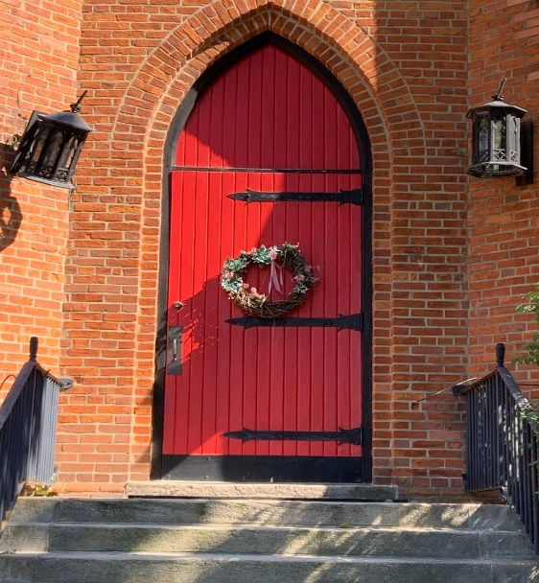

Trinity Parish
in the Episcopal Diocese of the Great Lakes
9 South 4th Street, Niles MI 49120
Office: (269) 683-6060
Email: trinityoffice5@yahoo.com
www.trinityniles.org
Office Hours: Tuesday & Thursday 10:00 a.m. – 2:00 p.m.

Vestry | Reader – Carol Krizinski
Kathy Davies, Sr. Warden | Acolyte – Carol Krizinski
Elizabeth Rossow, Jr. Warden | Organist – Roland Seguin
Rhiannon Sanford, Clerk | Social Media – John Garmire
Beverly Archer
Gini Hupp | Digital Vergers
Carol Krizinski | Rhiannon Sanford
Dr. Sandy Reed | Zoe Hatfield
Jim Pederson | Shandelle Henson

